## TABLES AND CONSTRAINTS

**Table Name: Department**

|  |  |  |
| --- | --- | --- |
| **Attribute** | **Data Type** | **Constraints** |
| Department Number | NUMBER (5) | PRIMARY KEY |
| Department Name | VARCHAR (25) | NOT NULL |

**Table Name: Employee**

|  |  |  |
| --- | --- | --- |
| **Attribute** | **Data Type** | **Constraints** |
| Employee Id | VARCHAR (15) | PRIMARY KEY |
| Name | VARCHAR (15) | NOT NULL |
| Address | VARCHAR (200) | NOT NULL |
| DOB | DATE | NOT NULL |
| Contact | NUMBER (10) | NOT NULL |
| Gender | CHAR (1) | CHECK (M/F) |
| Salary | NUMBER (10) | NOT NULL |
| Designation | VARCHAR (15) | NOT NULL |
| Department Number | NUMBER (5) | FOREIGN KEY references table department (Department Number) |

**Table Name: Patient**

|  |  |  |
| --- | --- | --- |
| **Attribute** | **Data Type** | **Constraints** |
| Patient Id | VARCHARR (25) | PRIMARY KEY |
| Name | VARCHAR (15) | NOT NULL |
| Address | VARCHAR (30) | NOT NULL |
| DOB | DATE | NOT NULL |
| Contact | NUMBER (10) | NOT NULL |
| Gender | CHAR (1) | CHECK (M/F) |
| Blood Group | VARCHAR (5) | NOT NULL |
| Room Assigned | VARCHAR (5) | FOREIGN KEY references table Room (Room Number) |

**Table Name: Login**

|  |  |  |
| --- | --- | --- |
| **Attribute** | **Data Type** | **Constraints** |
| User Name | VARCHAR (15) | UNIQUE |
| Password | VARCHAR (20) | NOT NULL |

**Table Name: Doctor**

|  |  |  |  |  |  |  |
| --- | --- | --- | --- | --- | --- | --- |
| **Attribute** | | **Data Type** | | | **Constraints** | |
| DOCTOR ID | | VARCHAR (15) | | | FOREIGN KEY references table Employee (Employee ID) | |
| Doctor Name | | VARCHAR (25) | | | NOT NULL | |
| Specialization | | VARCHAR (25) | | | NOT NULL | |
| **Table Name: Medical Report** | | | | | | | |
| **Attribute** | **Data Type** | | | **Constraints** | | | |
| Report Number | VARCHAR (25) | | | PRIMARY KEY | | | |
| Patient ID | VARCHAR (25) | | | FOREIGN KEY references table Patient (Patient Id) | | | |
| Admission Date | DATE | | | NOT NULL | | | |
| Discharge Date | DATE | | | NOT NULL | | | |
| Room Number | VARCHAR (5) | | | FOREIGN KEY references table Room (Room number) | | | |
| Diet | VARCHAR (10) | | | NOT NULL | | | |
| Payment | NUMBER (15) | | | NOT NULL | | | |
| **Table Name: Room** |  | | |  | | | |
| **Attribute** | **Data Type** | | | **Constraints** | | | |
| Room Number | VARCHAR (5) | | | PRIMARY KEY | | | |
| Status | VARCHAR (15) | | | CHECK (Occupied/Vacant) | | | |
| Room Type | VARCHAR (15) | | | NOT NULL | | | |
| **Table Name: Accompanies** | | | | | | | | |
| **Attribute** | | | **Data Type** | | | **Constraints** | | |
| Patient ID | | | VARCHAR (25) | | | FOREIGN KEY references table Patient (Patient Id) | | |
| Accompany name | | | VARCHAR (25) | | | DEFAULT NULL | | |
| Accompany Address | | | VARCHAR (200) | | | DEFAULT NULL | | |
| DOB | | | DATE | | | DEFAULT NULL | | |
| Contact | | | NUMBER (10) | | | DEFAULT NULL | | |
| Gender | | | CHAR (1) | | | CHECK (M/F) | | |
| Relationship | | | VARCHAR (15) | | | DEFAULT NULL | | |

|  |  |  |
| --- | --- | --- |
| **Table Name: Attended By** | | |
| **Attribute** | **Data Type** | **Constraints** |
| Patient ID | VARCHAR (25) | FOREIGN KEY references table Patient (Patient Id) |
| Doctor ID | VARCHAR (15) | FOREIGN KEY references table Employee (Employee ID) |
| Admission Date | DATE | NOT NULL |

**Table Name: Bill Details**

|  |  |  |
| --- | --- | --- |
| **Attribute** | **Data Type** | **Constraints** |
| Bill Number | VARCHAR (15) | PRIMARY KEY |
| Bill Date | DATE | NULL NULL |
| Patient ID | VARCHARR (25) | FOREIGN KEY |
| Admission Date | DATE | NOT NULL |
| Discharge Date | DATE | NOT NULL |
| Room Charges | NUMBER (10) | NOT NULL |
| Doctor Fees | NUMBER (10) | NOT NULL |
| Report Fees | NUMBER (10) | NOT NULL |
| Miscellaneous Fees | NUMBER (10) | NOT NULL |
| Total Amount | NUMBER (10) | NOT NULL |

## SQL Create table Queries

DEPARTMENT

create table department(

dep_no number(5) primary key,

dep_name varchar(25) not null);

EMPLOYEE

create table employee(

employee_id varchar(10) primary key,

employee_name varchar(25) not null,

address varchar(200) not null,

employee_dob date not null,

employee_contact number(10) not null,

gender char(1) check(gender in ('M','m','F','f')),

salary number(10) not null,

designation varchar(15) not null,

dep_no number(5) references department(dep_no));

ROOM

create table room(

room_no varchar(5) primary key,

room_type varchar(15) not null,

status varchar(10) check(status in('occupied','vacant')));

PATIENT

create table patient(

patient_id varchar(25) primary key,

patient_name varchar(25) not null,

address varchar(100) not null,

patient_dob date not null,

contact number(10) not null,

gender char(1) check(gender in('M','m','F','f')),

blood_group varchar(5) not null,

roomassigned varchar(5) references room(room_no)

);

LOGIN

create table login(

username varchar(15) unique,

password varchar(20) not null

);

DOCTOR

create table doctor(

doctor_id varchar(15) references employee(employee_id),

doctor_name varchar(25) not null,

specialization varchar(25) not null,

consulting_fee int(5) not null

);

MEDICAL REPORT

create table medical report(

report_no number(15) primary key,

patient_id varchar(25) references patient(patient_id),

admission_date date not null,

discharge_date date not null,

room_no varchar(5) references room(room_no),

diet varchar(10) not null,

payment number(15) not null

);

accompany

create table accompanies(

patient_id varchar(25) references patient(patient_id),

accompany_name varchar(25) default NULL,

acc_address varchar(200) default NULL,

acc_dob date default null,

acc_contact number(10) default null,

acc_gender char(1) check(acc_gender in('m','M','F','f')),

relationship varchar(15) default NULL

);

ATTENDED BY

create table attended_by(

patient_id varchar(25) references patient(patient_id),

doctor_id varchar(15) references employee(employee_id),

admission_date date not null

);

BILL DETAILS

create table bill_details(

bill_no varchar(15) primary key,

bill_date date not null,

patient_id varchar(25) references patient(patient_id),

admission_date date not null,

discharge_date date not null,

room_charges number(10) not null,

doctor_fees number(10) not null,

report_fees number(10) not null,

miscellaneous_fees number(10) not null,

total_amount number(10) not null

);

## SQL Insert Queries

**EMPLOYEE**

insert into employee values(‘101’,‘Sneha Jaiswal’, ‘Delhi’ , ‘19-10-93’, ‘9876543210’,‘F’,80000, ‘Nurse’,3);

insert into employee values(‘102’,‘Aditya Menon’, ‘Rohtak’, ‘20-01-91’, ‘7738014883’,’M’,100000, ‘Manager’,1);

insert into employee values(‘103’,‘Shivang Dogra’, ‘Gurgaon’, ‘12-04-82’,’2345678901’,’M’, 150000, ‘Doctor’,4);

insert into employee values(‘104’,‘Charik Goyal’, ‘Narwana’, ‘30-07-89’, ‘2341567890’,’M’, 350000, ‘Doctor’,4);

insert into employee values(‘105’,‘Muskaan Patel’, ’Surat’, ‘27-04-02’,’2356789170’,’F’,100000, ‘Receptionist’,2);

insert into employee values(‘106’,‘Prathyusha YDSS’, ’Hyderabad’, ’20 -10-93’, ‘1234567687’,’F’, 100000, ‘Pharmacists’,5);

insert into employee values(‘107’,‘Shamita Lal’, ‘Ooty’, ’07-07-92’, ‘2340567110’,’F’, 420000, ‘Doctor’,4);

insert into employee values(‘108’,‘Shweta Tiwari, ‘Jaipur’, ‘19-10-88’, ‘2340500891’,’F’, 150000, ‘Doctor’,4);

insert into employee values(‘109’,‘Rohit Sippy’, ‘Amritsar’, ‘05-05-89’, ‘2340567890’,’M’, 400000, ‘Doctor’,4);

insert into employee values(‘110’,‘Deepika Padukone’, ‘Chennair’, ‘25-05-87’, ‘2340561120’,’F’, 350000, ‘Doctor’,4);

**PATIENTS**

insert into patient values(‘1011’,‘Harsha Agrawal’,’Delhi’,’1999-10-21’,’9876543210’,’F’,’O+’,’201’);

insert into patient values(‘1022’,’Rushi Jain’,’Mumbai’,’2000-01-03’,’1234567890’,’M’,’B-’,’202’);

insert into patient values(‘1033’,’Shivani Mangla’,’Gurgaon’,’1998-04-02’,’2345678901’,’F’,’O-’, ’204’);

insert into patient values(‘1044’,’Simran Jha’,’Narwana’,’1999-07-08’,’2341567890’,’F’,’AB+’,’203’);

insert into patient values(‘1055’,’Raj Desai’,’Pune’,’2000-04-22’,’2356789170’,’M’,’O+’,’206’);

insert into patient values(‘1066’,’Preeti Chopra’,’Hyderabad’,’2000-10-13’,’1234567687’,’F’,’B+’,’207’);

**DOCTORS**

insert into doctor values(‘103’,’Shivang Dogra’,’Phycisian’);

insert into doctor values(‘104’,’Charik Goyal’, ’Surgeon’);

insert into doctor values(‘107’,’Shamita Lal ’,’Gynaecologist’);

insert into doctor values(‘108’,’Shweta Tiwari ’,’Therapist’);

insert into doctor values(‘109’,’Rohit Sippy’, ’Psychiatrist’);

insert into doctor values(‘110’,’Deepika Padukone’, ’Surgeon’);

**LOGIN**

insert into login values(‘BCE101’ ‘password’);

insert into login values(‘BCE102’, ‘smartaditya’);

insert into login values(’BIE103’,’shivdogra’);

insert into login values(’BEE107’,’goodworld’);

insert into login values(’BIT109’,’sharmaro’);

insert into login values(‘BCE104’, ‘charik199’);

**DEPARTMENT**

insert into department values(1,‘Management’);

insert into department values(4,‘Doctor’);

insert into department values(3,‘Nurse’);

insert into department values(2,‘Receptionist’);

insert into department values(5,‘Pharmacists’);

**MEDICAL REPORT**

Insert into medical_report values(‘10010101’,’103’,’03-05-15’,’06-05-15’,’G05’,’veg’,987564);

Insert into medical_report values(‘10010102’,’104’,’06-03-15’,’11-03-15’,’203’,’no-veg’,987862);

Insert into medical_report values(‘10010109’,’105’,’01-07-15’,’06-07-15’,’101’,’veg’,87568);

Insert into medical_report values(‘10010107’,’106’,’06-11-15’,’11-11-15’,’201’,’non-veg’,67564);

**ROOM**

Insert into room values(‘g01’,’deluxe’,’vacant’);

Insert into room values(‘g02’,’super deluxe’, ’occupied’);

Insert into room values(‘201’,’general ward’, ’vacant’);

Insert into room values(‘101’,’deluxe’,’occupied’);

Insert into room values(‘203’,’super deluxe’, ’vacant’);

**ACCOMPANIES**

insert into accompanies values(‘1011’,’Kunal Agrawal’,’kampoo lashkar gwalior’,’27-11-96’,’8889835825’,’M’,’brother’);

insert into accompanies values(‘1022’,’Anita Jain’,’janakganj amritsar ’,’06-02-69’,’9827671701’,’F’,’mother’);

insert into accompanies values(‘1033’,’Kamal Mangla’,’rajapark jaipur’,’27-09-76’,’8889835825’,’M’,’farther’);

insert into accompanies values(‘1044’,’Gopal Jha’,’borivali mumbai’,’20-12-86’,’8768835825’,’M’,’brother’);

**ATTENDED BY**

insert into attended_by values(‘1011’,’102’,’21-03-16’);

insert into attended_by values(‘1022’,’103’,’02-04-16’);

insert into attended_by values(‘1033’,’105’,’07-05-17’);

insert into attended_by values(‘1044’,’101’,’25-08-16’);

**BILL DETAILS**

Insert into bill_details values(

Insert into bill_details values(

Insert into bill_details values(

Insert into bill_details values(

Insert into bill_details values(

**DETAILS**

## Screenshots

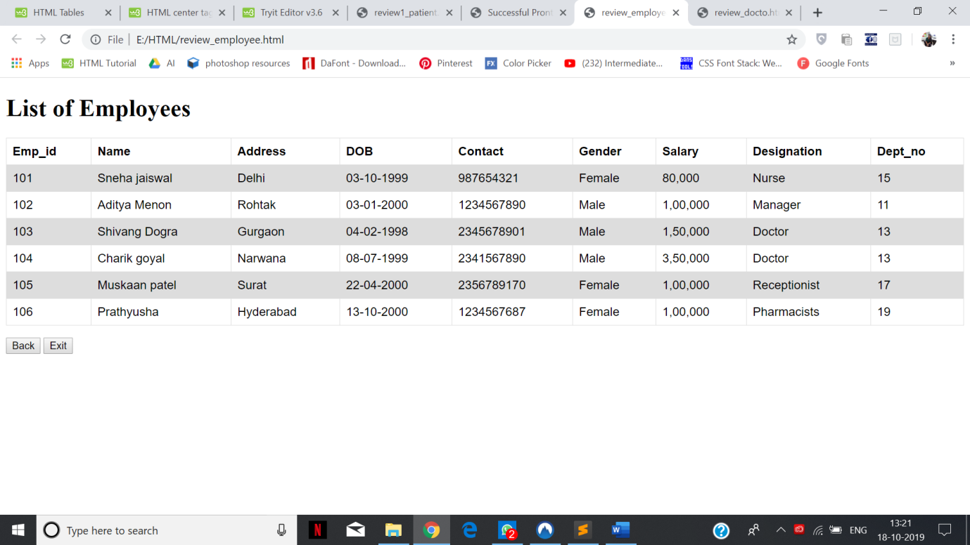

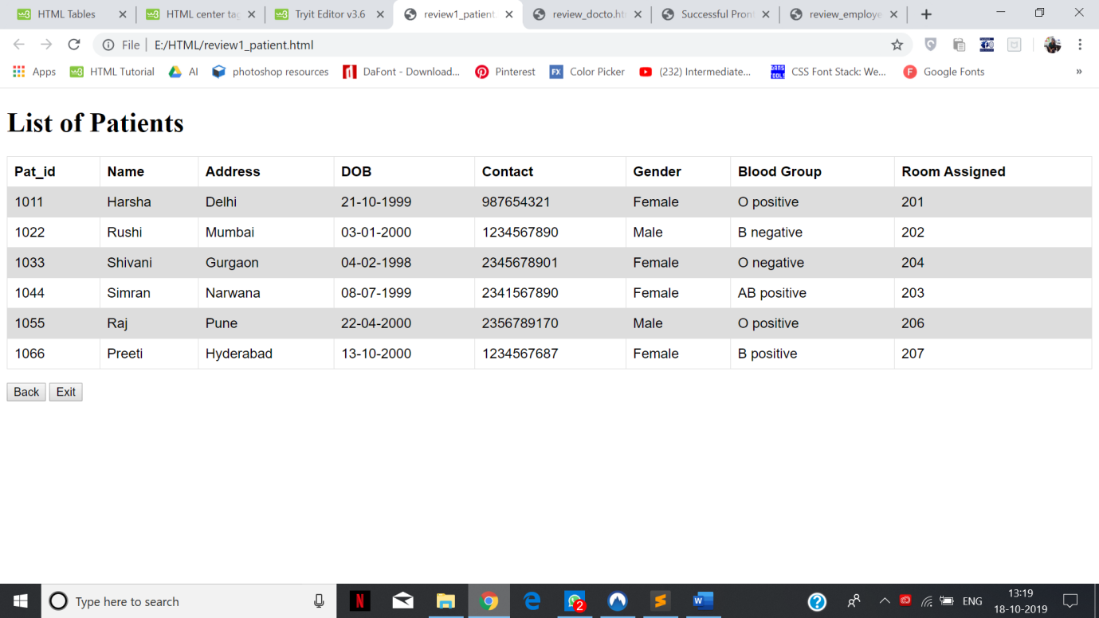

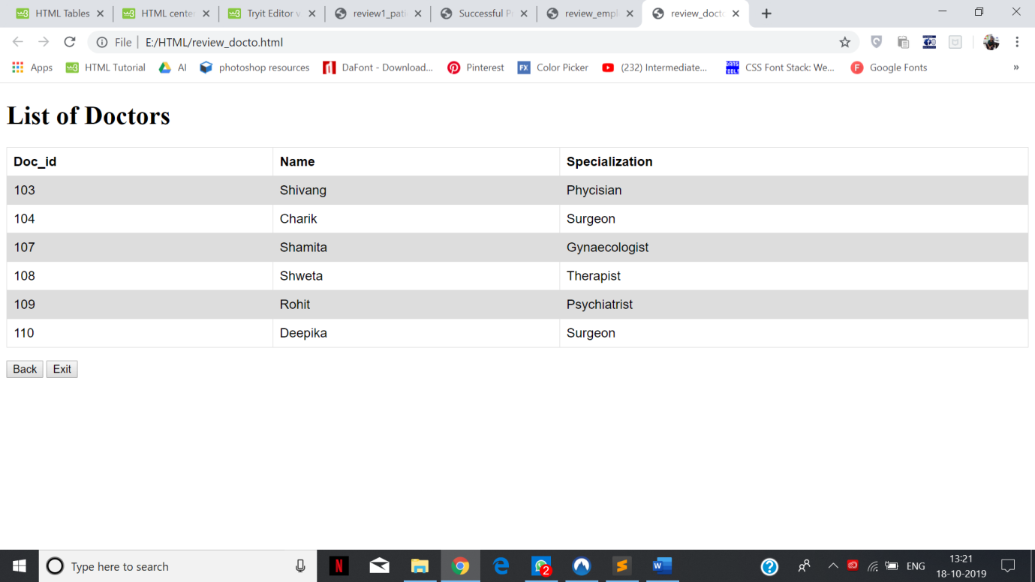

**TO DO:**

**Add search function to all table pages (by name or primary key)**

**Modify medical report and bill generation tables to include rates for rooms, doctors etc**